Sitecore Hackathon 2017

TEAM: Hey Bro, got a kidney?

CATEGORY: HABITAT

Microsoft Cognitive Services

Sitecore Hello (:

Table OF CONTENTS

Welcome to Sitecore Hello 3

Purpose 3

Installation 4

Usage 5

Saving a Reference Profile Picture 5

Login With Sitecore Hello 7

# Welcome to Sitecore Hello

Welcome to Sitecore Hello, a custom login module that uses the Microsoft Cognitive Services Face API to allow a user to log into a Sitecore site via facial recognition.

This module has been built following Helix guidelines and runs as a feature in the Habitat Demo site.

# Purpose

User names and passwords are complex to remember. Users tend to choose simple passwords or reuse the same ones on multiple websites. These are bad and insecure practices.

The ideal authentication mechanism should not require the user to remember anything. It should work with information that users already have. Excellent examples are fingerprints and retina scan. Facial characteristics are also a good way to identify a person.

The purpose of Sitecore Hello is to simplify user authentication on websites and increase their security at the same time.

# Installation

Sitecore Hello was developed in a Sitecore Habitat repository fork at <https://github.com/LonghornTaco/Habitat>

To install it locally, follow these steps:

1. Clone the repository to your local file system.
2. Configure your settings if you are using settings other than the defaults:
   1. The default settings for Habitat are
      1. URL: http://habitat.dev.local/
      2. Location: C:\Websites\Habitat.dev.local\
   2. To change the standard location of the source files, website files and website URL, modify the following files:
      1. **Please be aware to include or omit trailing slashes - as per the default**
      2. /Solution Items/src/Project/Habitat/code/App_Config/Include/Project/z.Habitat.DevSettings.config
      3. /Solution Items/gulp-config.js
      4. /Solution Items/publishsettings.targets
3. Set up a clean Sitecore install with the settings from the previous step
   1. We recommend using Sitecore Instance Manager for the install.
   2. Please note that the Sitecore executable installer does not support periods in the domain name and therefore if you are installing using this, please change the default domain (see step 2).
   3. Habitat requires:
      1. Sitecore Experience Platform 8.2 Update 1 in Experience Platform or Experience Management mode
      2. Webforms for Marketers 8.2 Update 1 module. It should be installed prior to running Sync Unicorn gulp task. Also you may need to have running mongo instance when installing WFFM module, otherwise it may lead to never ending installation dialogue window.
   4. Configure an additional IIS binding for the website to localhost on port 80 without any hostname. This is required for the webcam access from the web browser.
4. Restore Node.js modules
   1. Make sure you have version 4+ of node.js Download here
   2. In an elevated command window run 'npm install' in the root of repository.
5. Build the solution
   1. Open a command window with elevated privileges and run 'gulp' in the root of repository.
   2. Alternatively:
      1. Open Visual Studio 2015 in Administrator Mode
      2. Open the Visual Studio 2015 Task Runner Explorer pane (View | Other Windows | Task Runner Explorer).
      3. Switch to "Solution 'Habitat'"
      4. Run the "default" task
6. Publish the Sitecore master database to the web database.

# Usage

## Saving a Reference Profile Picture

After creating an account or logged in the website, the user can optionally enable Sitecore Hello by saving a reference profile picture.

1. Navigate to the Sitecore Hello page at <http://localhost/sitecore-hello>

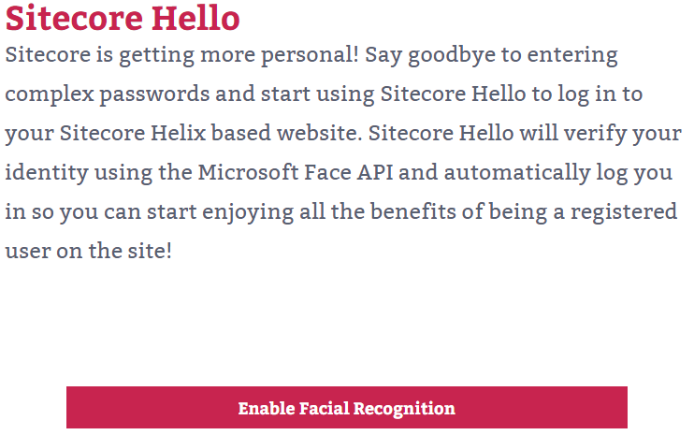

1. Click the Enable Facial Recognition button
2. Grant the web browser the permission to use the webcam by clicking on Allow. The captured video will be displayed.

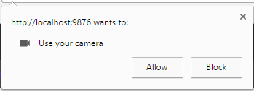

1. Follow the instructions on screen

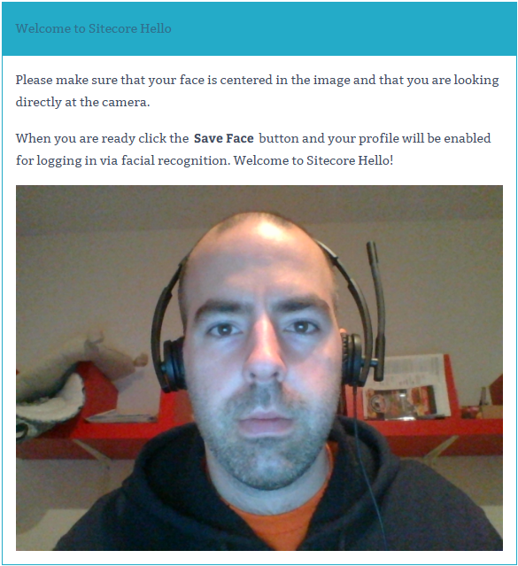



1. Make sure that your face is centered in the image and that you are looking directly at the camera
2. When you are ready click the Save Face button
3. A success message is displayed under the button
4. Your picture is saved and your profile is enabled for logging in via facial recognition

## Login With Sitecore Hello

After enabling Sitecore Hello and logged out the website, the user can optionally log in using Sitecore Hello.

1. From the Habitat website header menu, click the rightmost icon to navigate to the Sitecore Hello login page. You can also navigate directly to it at <http://localhost/login-with-hello>



1. If asked, grant the web browser the permission to use the webcam. The captured video will be displayed.

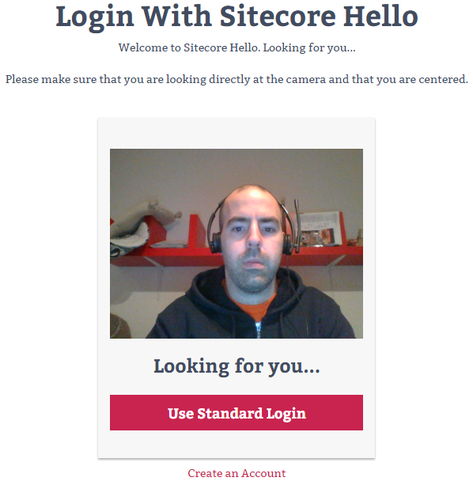

1. Follow the instructions on screen
2. Make sure that you are looking directly at the camera and that you are centered.
3. The page will attempt to identify you by taking a snapshot every 2 seconds.
   1. If the facial identification is successful, you will be logged in and redirected to the website home page.
   2. If after 10 tries, the system still do not recognizes you, an error message is displayed. You will be invited to click the Use Standard Layout button to log in with your username and password. It is then recommended to take a new reference profile picture.